Space Museum

Technical Document

Jufeng Li

2020 . 1

Category

1 Introduction 3

1.1 Profile 3

1.2 Introduction 3

2 Project function module 4

2.1 Module design 4

3 Core technology realization 4

3.1 Kinect 4

3.2 Implementation of several gestures 5

3.3 UI 6

3.4 Orbiting part of the planet 6

# Introduction

1. Profile

Project name：Space Museum

Project Development Environment：

Development of the engine Unity

Hardware support：Kinect、音响、摄像头、投影仪

User：12+

Picture style: 3D

1. Introduction

The scene simulates the real structure of the universe, and with the help of Kinect and projector, the user is projected into the universe, giving the user a feeling of exploration in the universe.

The program reads the user's actions, so that the user can move freely in the universe, and can interact with the planet according to the characteristics of the planet, and view the relevant information of the planet.

# Project function module

1. Module design

|  |  |
| --- | --- |
| System function module | Functions overview |
| Laboratory display | Includes Settings and help screens for better user experience. The main menu plays video of galaxy exploration to enhance user immersion |
| UI | The overall use of technology style design, in line with the theme of space exploration, with appropriate light and smoke effects beautify the interface |
| The movement of the planet | Simulate the rotation and revolution of the planet, with the character as the center, you can control the revolution pause and run, aspect view and enter the planet |
| Planet interactions | After entering the planet to increase the exploration elements, introduce the basic knowledge of the planet and interesting things to help users better understand and explore, increase interest and interaction |
| Information popup window | Operation point touching the planet will pop up the general introduction of the planet and whether to enter the interactive button |
| Scene switching | Multi-level scene switching allows users to exit and enter at any time to optimize the experience effect |

# Core technology realization

1. Kinect

KinectManager：

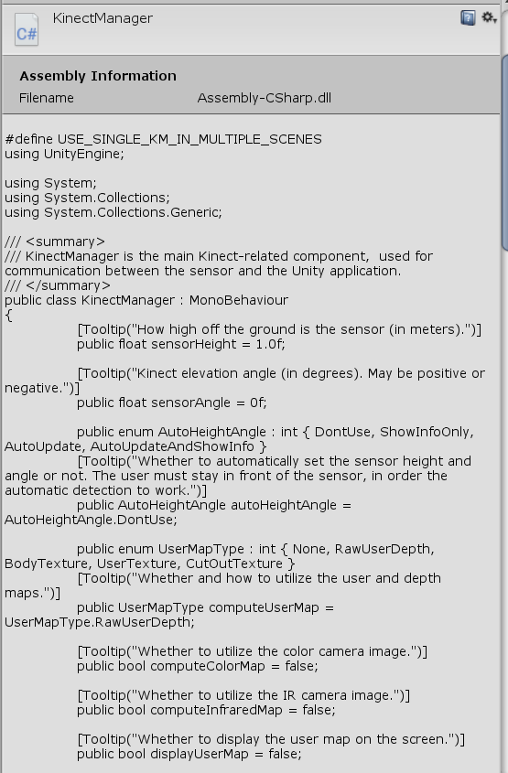

1. Implementation of several gestures

grab

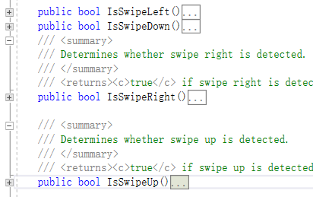

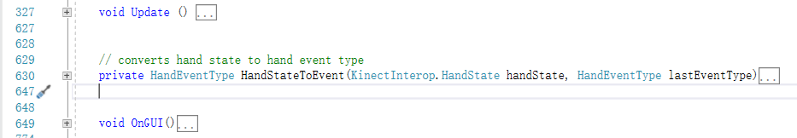

**All scripts of gestures’ interactions**

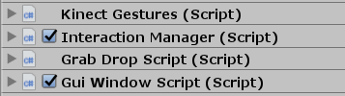



1. UI

animations

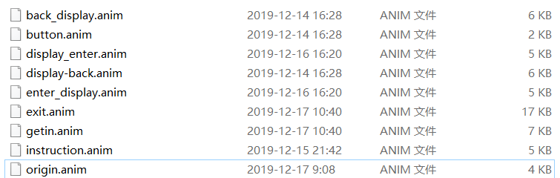

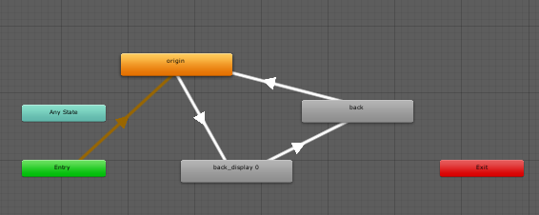

scripts

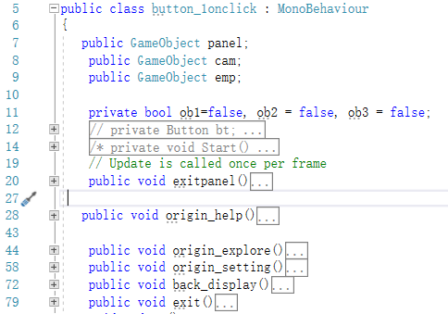

Include all of the UI click interactions

1. Orbiting part of the planet

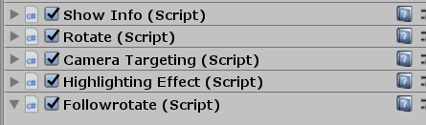

Showinfo showing a brief introduction to the planet

Rotate rotation

Followrotate revolution

highlight Controls selection highlighting

Key code of revolution

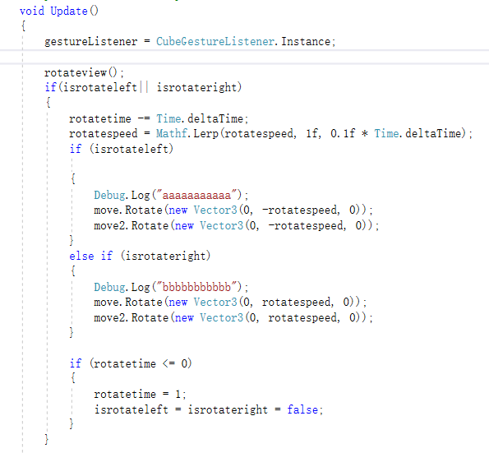

Key code of rotation

